Co-curricular Activities -

INVESTITURE CEREMONY:-

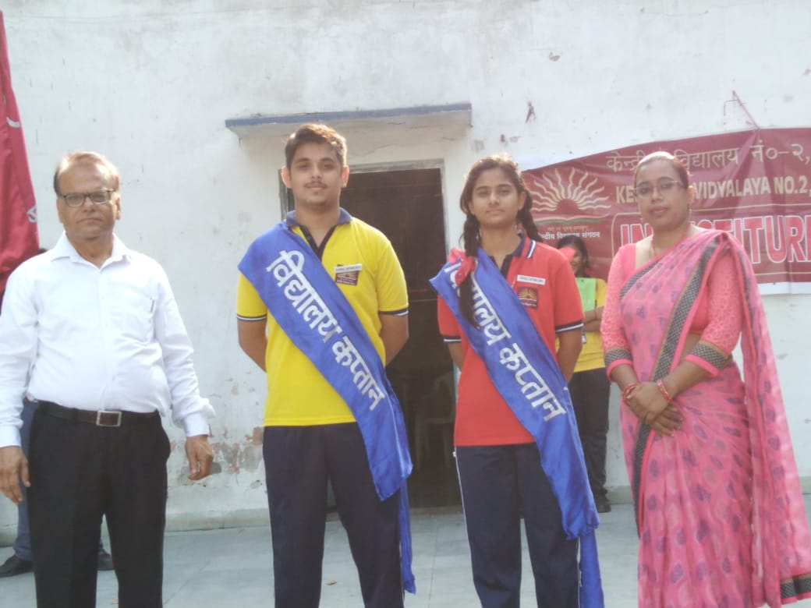

INDEPENDENCE DAY CELEBRATION

HINDI PAKHWARA CELEBRATION
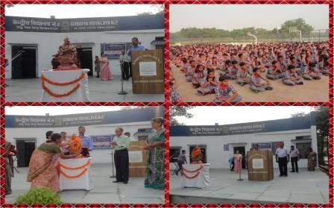

RAKSHABANDHAN CELEBRATED
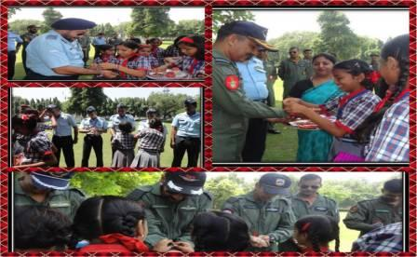

VIDYALAYA ENTRANCE AND SURROUNDINGS
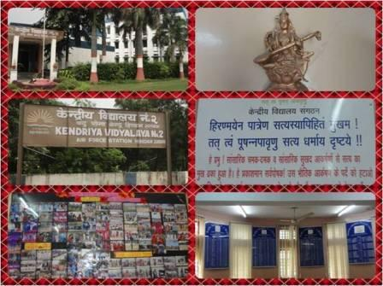

PAINTING DRAWN BY STUDENTS
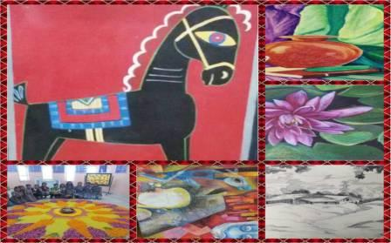

PAINTINGS DRAWN BY STUDENTS
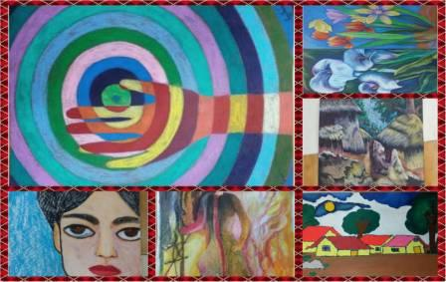

PAINTINGS DRAWN BY THE STUDENTS
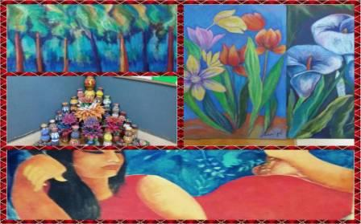

GREENS OF VIDYALAYA
