Student Creative Corner -

CREATIVE ART BY OUR STUDENTS
Poster
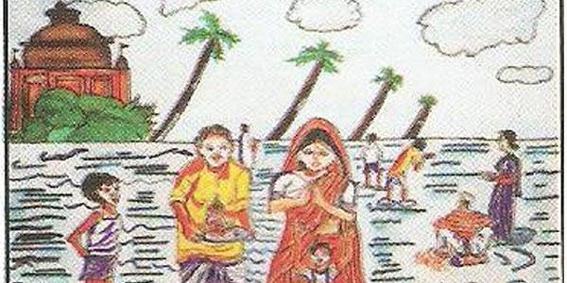
By :Daksh Sharma Class V
Poster
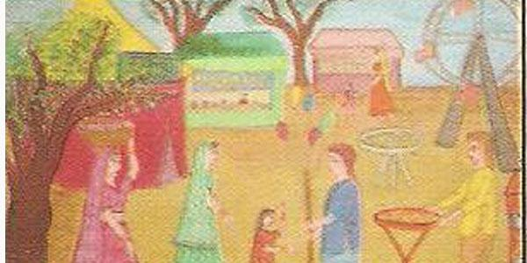
By :Roopa Shree Class VIII
Poster
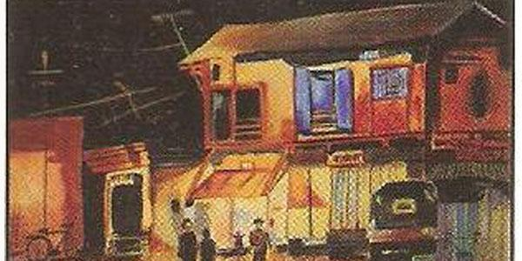
By :PrithaMondal Class X
Rangoli
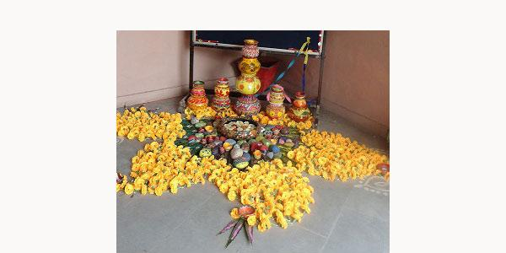
By : By our students
Rangoli
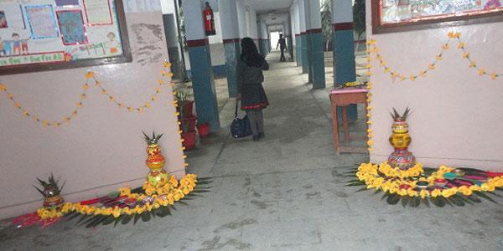
By : By our Students
Rangoli
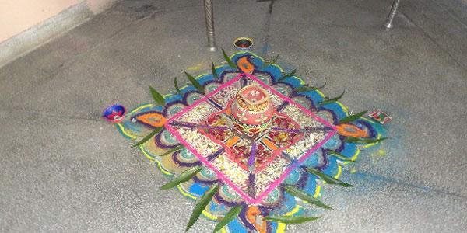
By : By our students
Rangoli
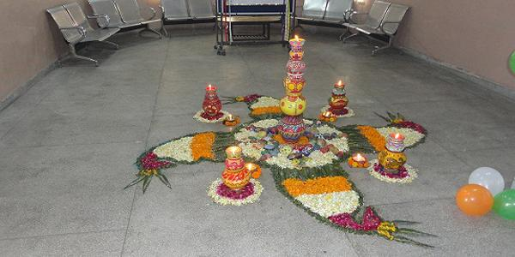
By : By our Students

